CPU Configuration and Performance Monitoring in Ubuntu

1. lscpu
Description: Displays CPU architecture, processor model, number of CPU cores, threads, and other processor details.
Lscpu
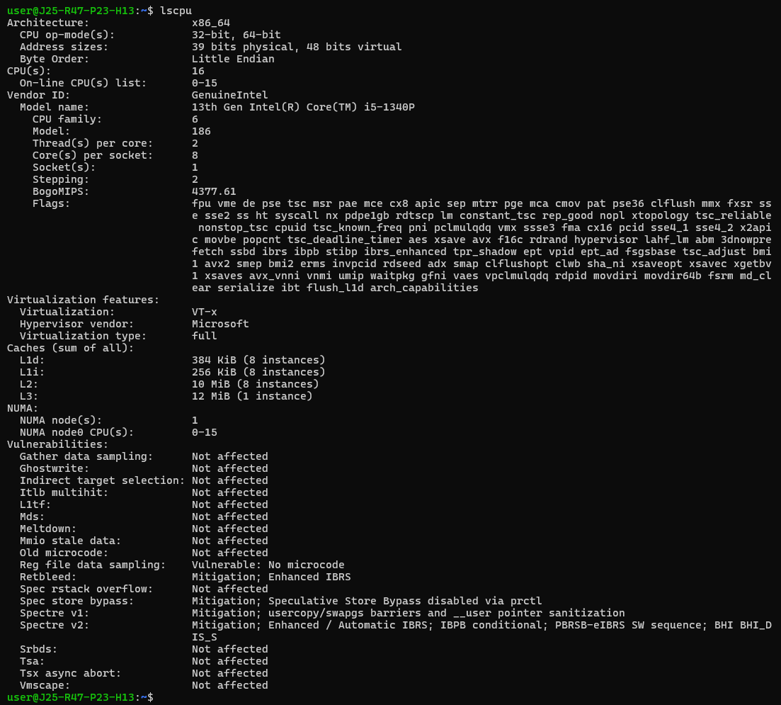

2. nproc
Description: Displays the number of processing units available to the current environment.
Nproc
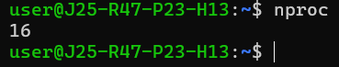
3. cat /proc/cpuinfo
Description: Displays detailed information about each logical CPU, including its model name, processor ID, and clock speed details.
cat /proc/cpuinfo
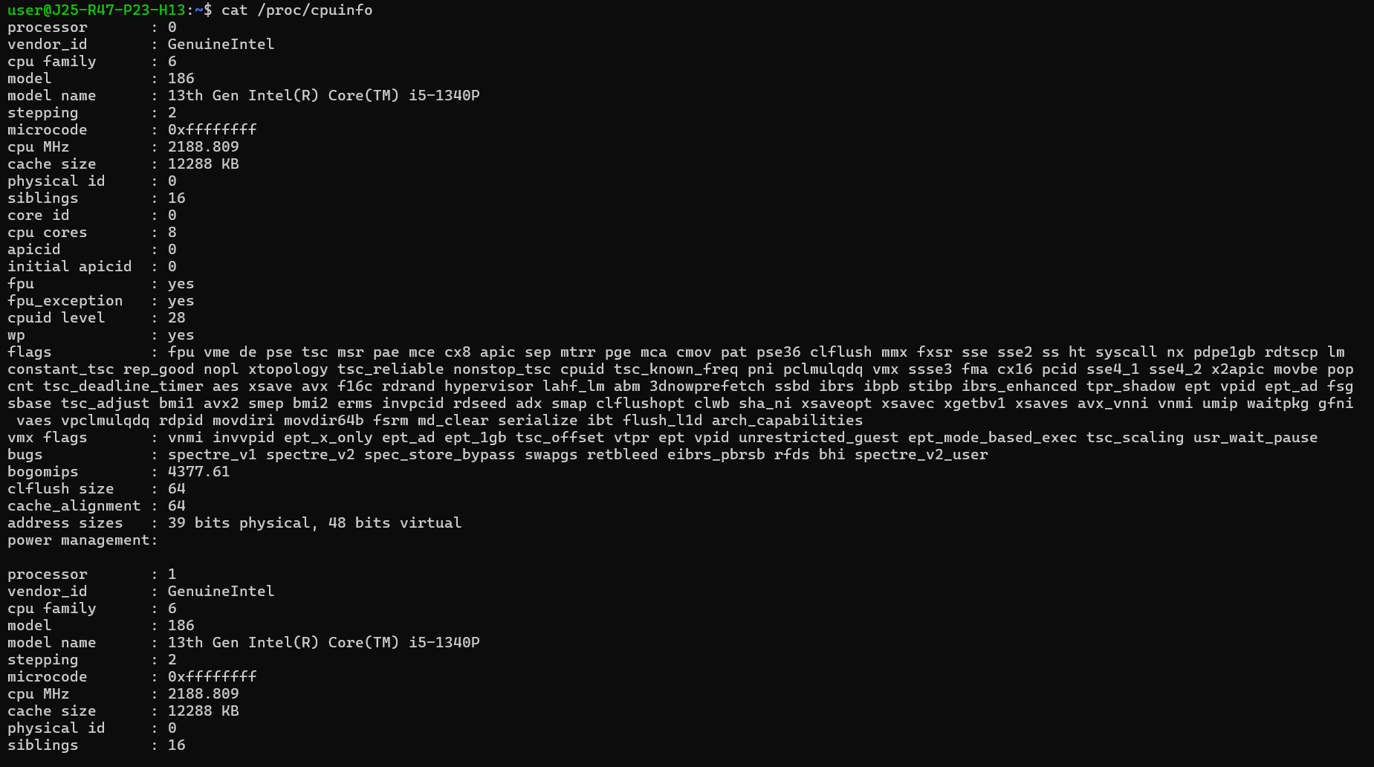
To display only the processor model:
grep "model name" /proc/cpuinfo
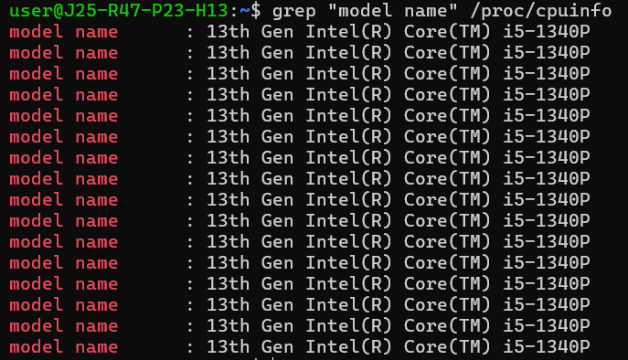

4. uptime
Description: Displays the system running time, number of logged-in users, and system load averages for the last 1, 5, and 15 minutes.
Uptime
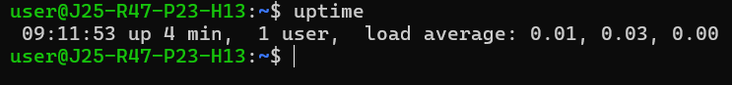
5. top
Description: Displays real-time CPU utilization, memory usage, system load, and running processes.
Top
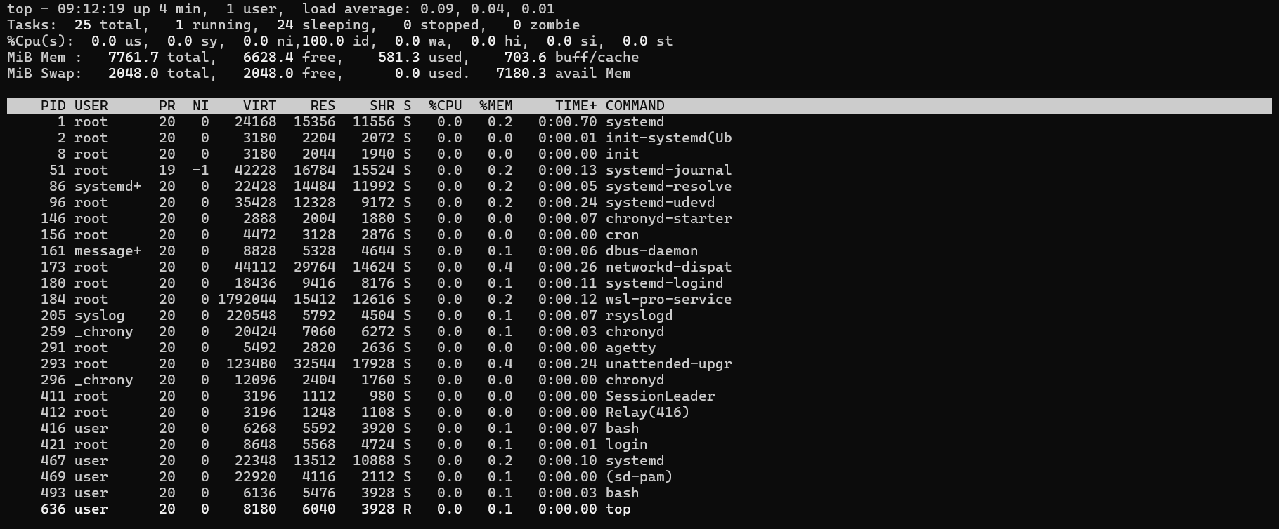
Press q to exit.
6. htop
Description: Provides an interactive view of CPU usage per core, memory utilization, and running processes.
htop
If it is not installed:
sudo apt update && sudo apt install htop
7. mpstat
Description: Displays CPU utilization statistics, including user, system, idle, and I/O-wait percentages.
mpstat -P ALL 1 5
If the command is unavailable:
sudo apt install sysstat

8. vmstat
Description: Reports system performance statistics, including CPU activity, memory usage, running processes, and I/O activity.
vmstat 1 5
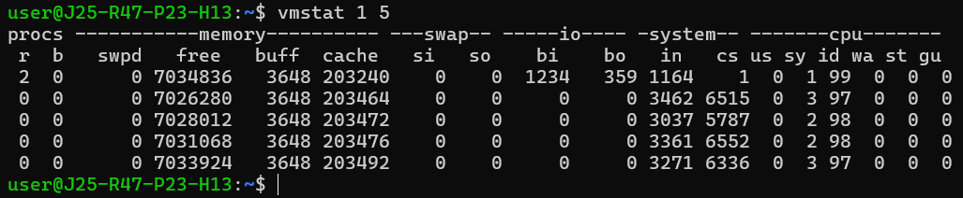
9. ps
Description: Displays information about running processes, including their process IDs and CPU and memory utilization.
ps -eo pid,comm,%cpu,%mem --sort=-%cpu | head
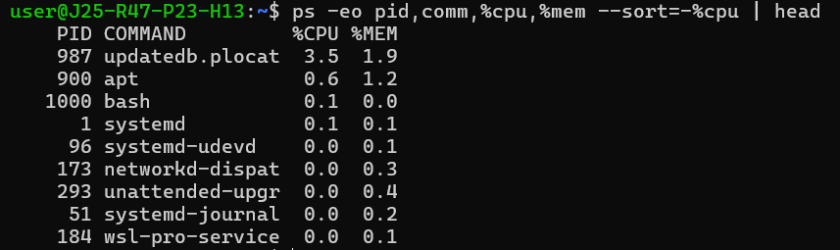
10. cat /proc/loadavg
Description: Displays the system load averages for 1, 5, and 15 minutes, along with process and scheduling information.
cat /proc/loadavg
11. free -h
Description: Displays total, used, available, and free memory in human-readable units.
free -h
Focus on the available memory value to estimate how much memory is available for new applications without swapping.
12. df -h
Purpose: Displays filesystem disk capacity, used space, and available space in human-readable units.
df -h
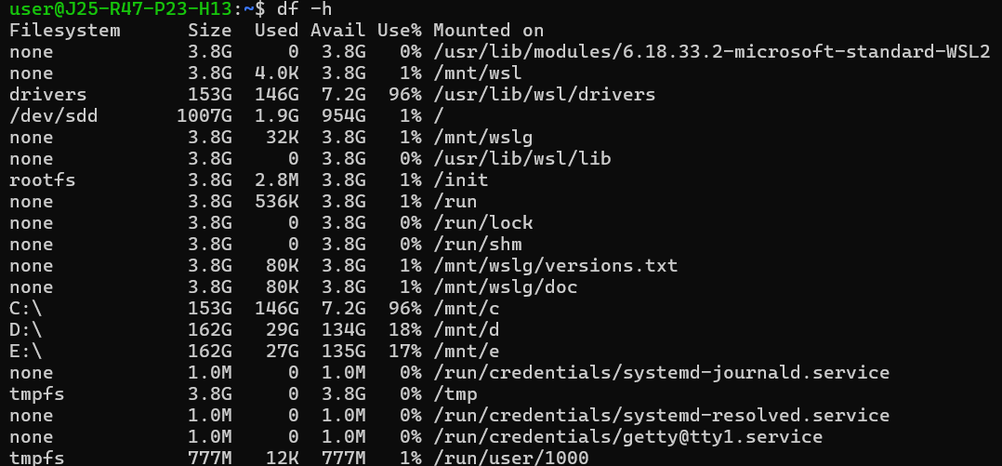

Checklist:
No. | Validation item/name | Expected result | Status
11 | Disk Space | Sufficient free disk space available | ✓ Yes
12 | Security Updates | Required security updates installed | ✓ Yes
13 | IAM Permissions | Least-privilege access configured | ✓ Yes
14 | CloudWatch Monitoring | CPU and status monitoring configured | No
15 | Auto-Recovery | Recovery mechanism verified or configured | No

